**019 global inventory of qualifications frameworks is out!**

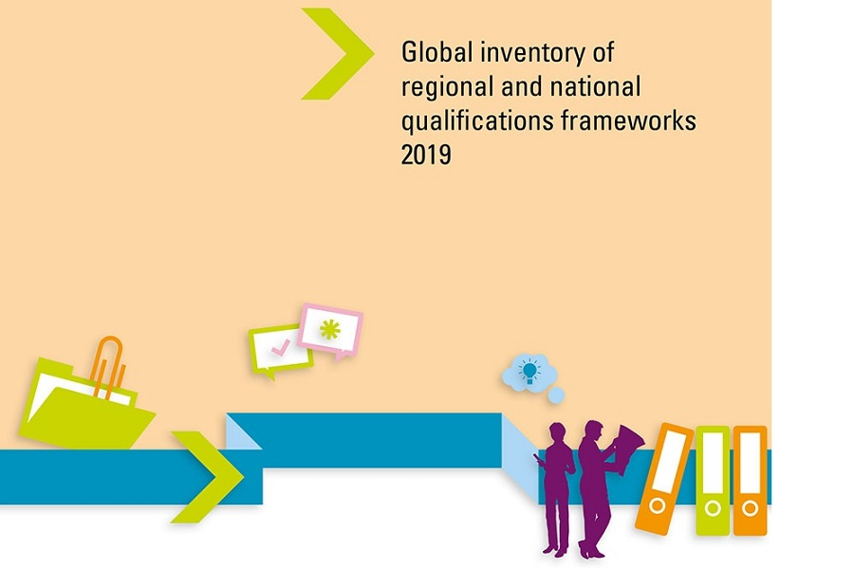

**A collaborative work of Cedefop, UNESCO, ETF and UNESCO’s Institute for Lifelong learning, the *Global inventory of national and regional qualifications frameworks* captures and analyses global trends in qualifications frameworks.**

The 2019 update is the inventory’s fourth edition, consisting of two volumes:

* [**Vol 1: six thematic chapters**](https://www.cedefop.europa.eu/en/publications-and-resources/publications/2224-0);
* [**Vol 2: 102 individual country descriptions and seven regional qualifications frameworks**](https://www.cedefop.europa.eu/en/publications-and-resources/publications/2225).

The inventory gathers information on progress in establishing national and regional qualifications frameworks, and on the challenges and success factors in implementation. It monitors how countries around the globe are reforming their education systems by improving the quality and relevance of their qualifications.

Among the inventory’s uses is to inform decisions by ministries, authorities and other actors; and to share knowledge with a worldwide network of experts and officials implementing national or regional qualifications frameworks.

National chapters include snapshots of progress in qualifications reforms. The country cases look at the educational, social, economic and political context in which the national qualifications framework (NQF) is embedded, the main policy objectives, learning outcomes’ implementation, stakeholder involvement and institutional arrangements.

The NQFs support the goals of UNESCO’s Education 2030 agenda, a framework for action that reinforces implementation of [**sustainable development goal 4**](https://sustainabledevelopment.un.org/sdg4): to ensure inclusive and equitable quality education and promote lifelong learning opportunities for all. Learning-outcomes-based qualifications frameworks can contribute directly to this goal.

In 2016, the European Commission adopted the *New skills agenda for Europe* with actions to improve the quality and relevance of skills for citizens and the labour market. The skills agenda underlines the need to continue developing the European qualifications framework (EQF), noting the progress made after 2008. The revised EQF (adopted in 2017) is expected to play a key role in taking forward EU skills and lifelong learning strategies, directly aiding transparency and portability of qualifications in Europe.

New regional frameworks are now becoming operational. The Association of Southeast Asian Nations qualifications reference framework has attained operational status. Initiatives in Africa, the Caribbean and the Pacific area also illustrate this tendency.

**2019 update findings**

* Global trends, such as internationalisation, digitalisation, migration and mobility, are changing the education and qualifications systems as we know them.
* Digital learning is spreading across the world, changing the relationship between formal/traditional qualifications and digital credentials.
* The learning outcomes concept (skills and knowledge that learners acquire as a result of learning) is becoming a common basis for almost all national and regional qualifications frameworks worldwide.
* The spread of the NQFs has helped the validation and recognition of knowledge, skills and competences acquired in a non-formal setting.
* Qualifications frameworks and reform have contributed to greater transparency of qualification systems and better access to lifelong learning opportunities.
* An important challenge for the coming years is for NQFs to keep up with digitalisation, establishing trust across national and regional borders.